# Lab 16: Input, Output and Exceptions

## Objective

In this lab, we will take advantage of the **java.io** package in order to add more flexibility to our **Inventory** system class.

## Overview

In this lab you will:

* Populate a file with information about books.
* Read from that file and use the information to create Book objects.
* Exercise your code to ensure it is working correctly.

## Step by Step Instructions

**Exercise 1: Reading Information From a File**

For our Inventory system, we’d like to load our **Inventory** from a text file. Doing so for all of the different inventory types would be a lengthy exercise and we will leave that open as a challenge to the student with time on his/her hands. Instead we will simply load some **Book** objects.

1. Create a new class named **BookExerciser** in project Store and package com.javaoo.store. Ensure that this new class has a main() method. Create a variable in the main() method of type **List<Book>** named books. Remember to import java.util.*.
2. Add a method named readBooksFromFile() in the **BookExerciser** class. This method will be used to populate our **List<Book>** with book information that is read from a file. It should have the following signature:

public List<Book> readBooksFromFile(String name)

1. We are going to store information about our book inventory in a text file. We will pass the name of the text file to the readBooksFromFile() method. The first thing we need to do is open the file and ensure that we can read from it. We would like to read from the file line by line so we will do that with a **LineNumberReader** object. Do the following:
   1. Import java.io.*;
   2. Create a **FileInputStream** from the file name passed into readBooksFromFile()
   3. Create an **InputStreamReader** from the **FileInputStream**
   4. Create a **LineNumberReader** from the **InputStreamReader**
   5. Ensure that all of this is done inside of a try block
   6. This portion of the code should look as follows:

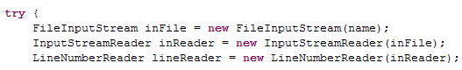

1. Add a simple while loop to go through the file line by line and output the information to the console. Add a catch block to handle any exceptions of type **IOException** that might be generated by the code that is opening and reading the file. The entire method at this point should look as follows:

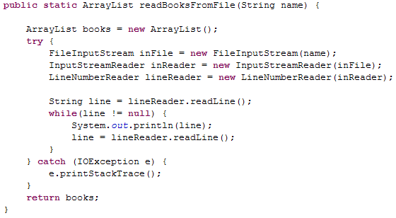

1. Now we’ll need to set up the text file to hold **Book** information Using the New→File wizard, create a text file named books.txt. Add some books to the text file. To keep it simple we’ll store title, author and price. Put one piece of data per line and add two or three books.   
     
   Here’s an example of what the file should look like:  
     
   COBOL for Java Programmers  
   Isaac B. Mortimer  
   45.95  
   3D Game Programming for the IPod  
   Hawley Smoot  
   111.95

Save the file;

1. In the main() method of BookExerciser, create a String variable called location. Right click on books.txt in the Package Explorer, select Properties and copy the file location from the wizard.

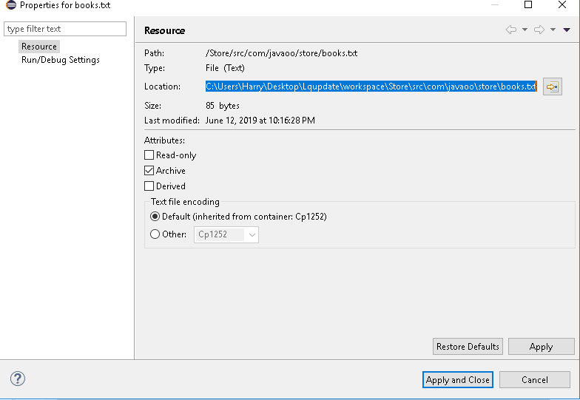

Select cancel. Paste the clipboard as a value for the location variable;

1. In the main() method in **BookExerciser**, call the readBooksFromFile() method, passing it location as the file name. (Backslash means ‘escape the next character’ in Java so we need to escape the backslash.) Your main method should look as follows:



Note: We are not really populating the **ArrayList** at this point. We will do that next.

1. Execute the program. You should see the contents of your text file in the console.
2. For each book, we’re going to read three lines of text and the third line will need to be converted to a double. Think carefully about the logic you’ll need to make this work (assuming all the data in the file is correct). Look at the **Double** class in java.lang for guidance. Modify the while loop so that it reads the data three lines at a time storing each piece of information in a local variable. Print out each of these local variables after the 3rd line is read to ensure you are parsing the data correctly.
3. Now we need to use that data and create a **Book** object. You can use the constructor that takes all 6 fields. Set the quantity to **5**, the publisher to **null** and the category to **NON-FICTION**. Place the book in the **ArrayList** books.
4. Add a loop to your main() method to print out the titles of all of the books in the books collection. Here is how your main() method should look.

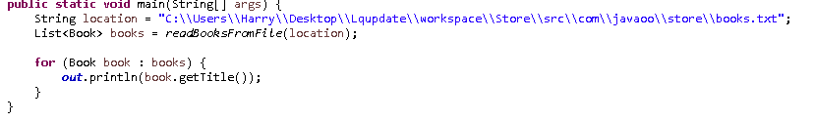

1. Execute the program and ensure that it prints out your titles.

**Challenge Exercise**

1. What happens if the file does not contain valid data? Experiment with different techniques for detecting bad data, and more importantly, recovering from it. This is a very open-ended problem and can be one of the most challenging aspects of writing good code.